 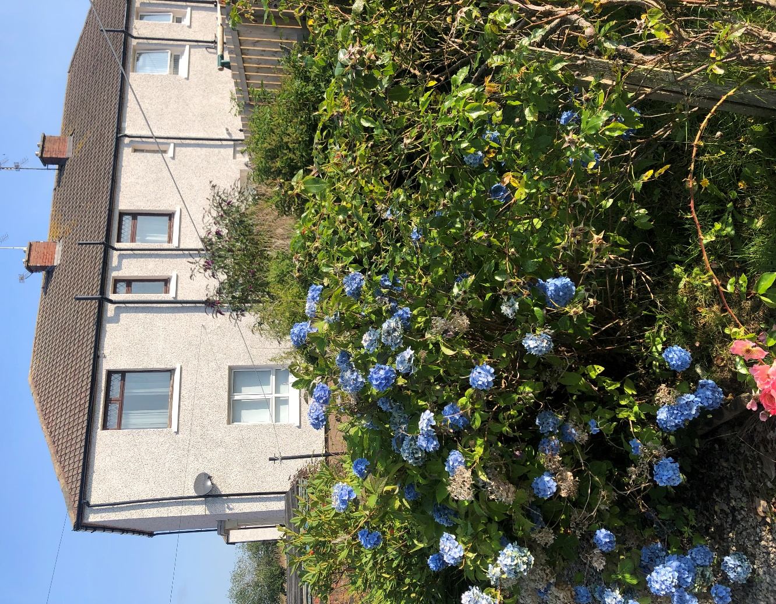

2 Bedroom upper flat in the popular village of Mossblown.

Rent £450.00 per month.

EPC Band C

Council Tax band A

**Features**

First Floor property

Shower Cubicle

Double Glazed

Carpet /Laminate Flooring

Large back garden

Pets Allowed

Large storage cupboards

Blinds on all windows

Electric Hob

Gas Central Heating

Electric oven

Unfurnished

**Description**

Your Choice Lettings and Property Managementare delighted to present to the rental market this 2-bedroom first floor, four in a block, property which located in Drumley Drive within the popular village of Mossblown.

This light spacious flat has a large front facing lounge, 2 good sized double bedroom to the front and rear of property and a 3 piece bathroom suite with chrome shower enclosure and chrome towel rail. Fully fitted kitchen with built in electric cooker and hob.

The flat offers a neutral décor throughout with a few accent colours, carpet flooring throughout property except the bathroom & kitchen which has laminate flooring. The property also has a large fully enclosed garden to the side and rear of the property which has a driveway, patio area and a small shed.

The local area has a range of amenities as well as being close to surrounding villages and is a short bus ride to Ayr town centre.

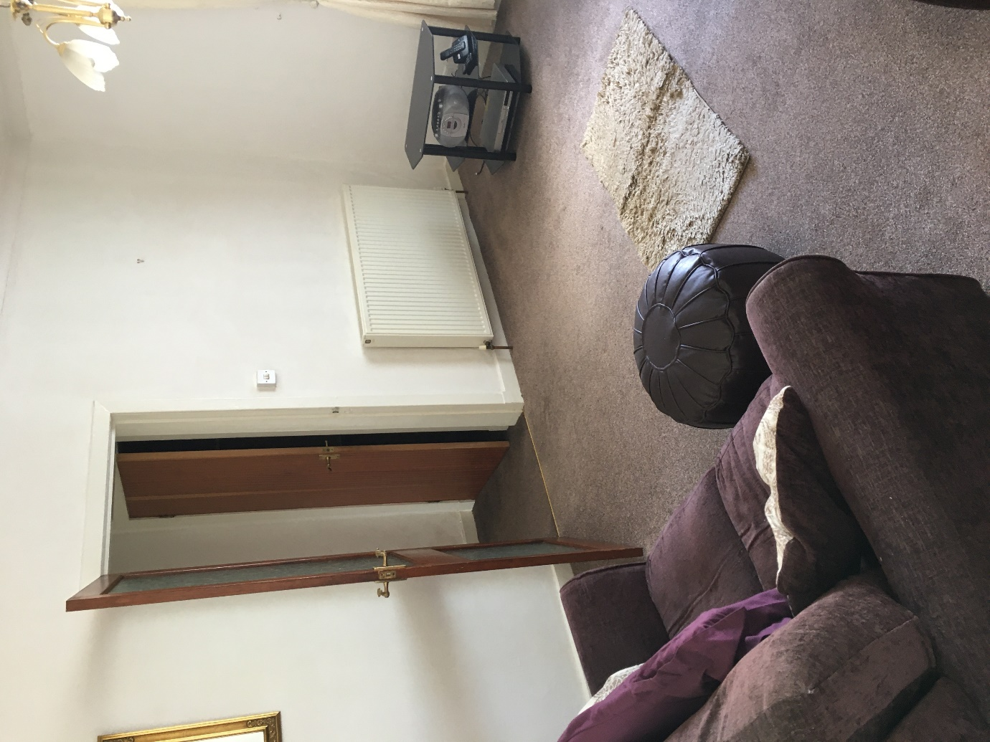

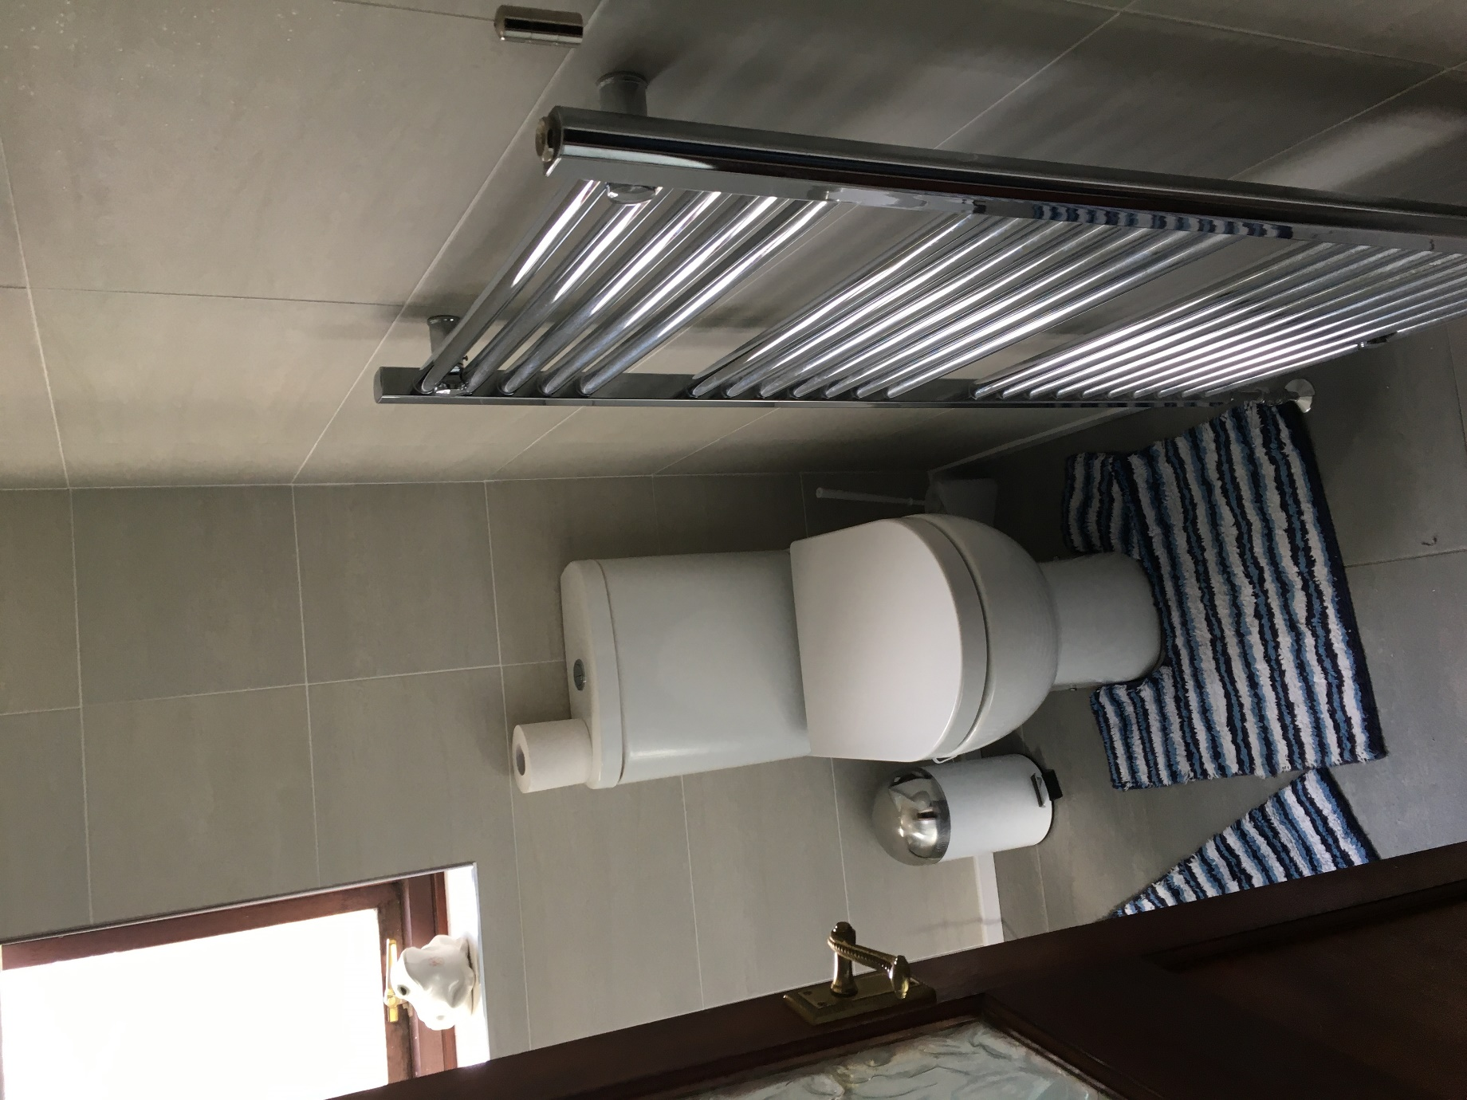

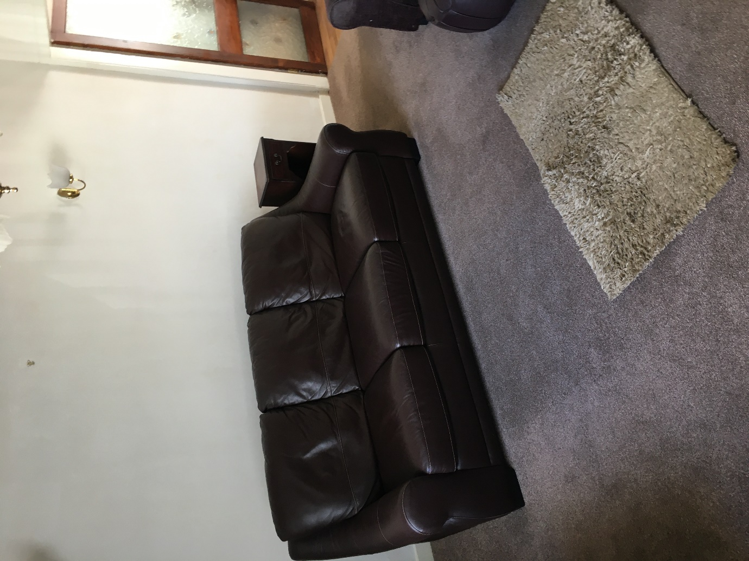

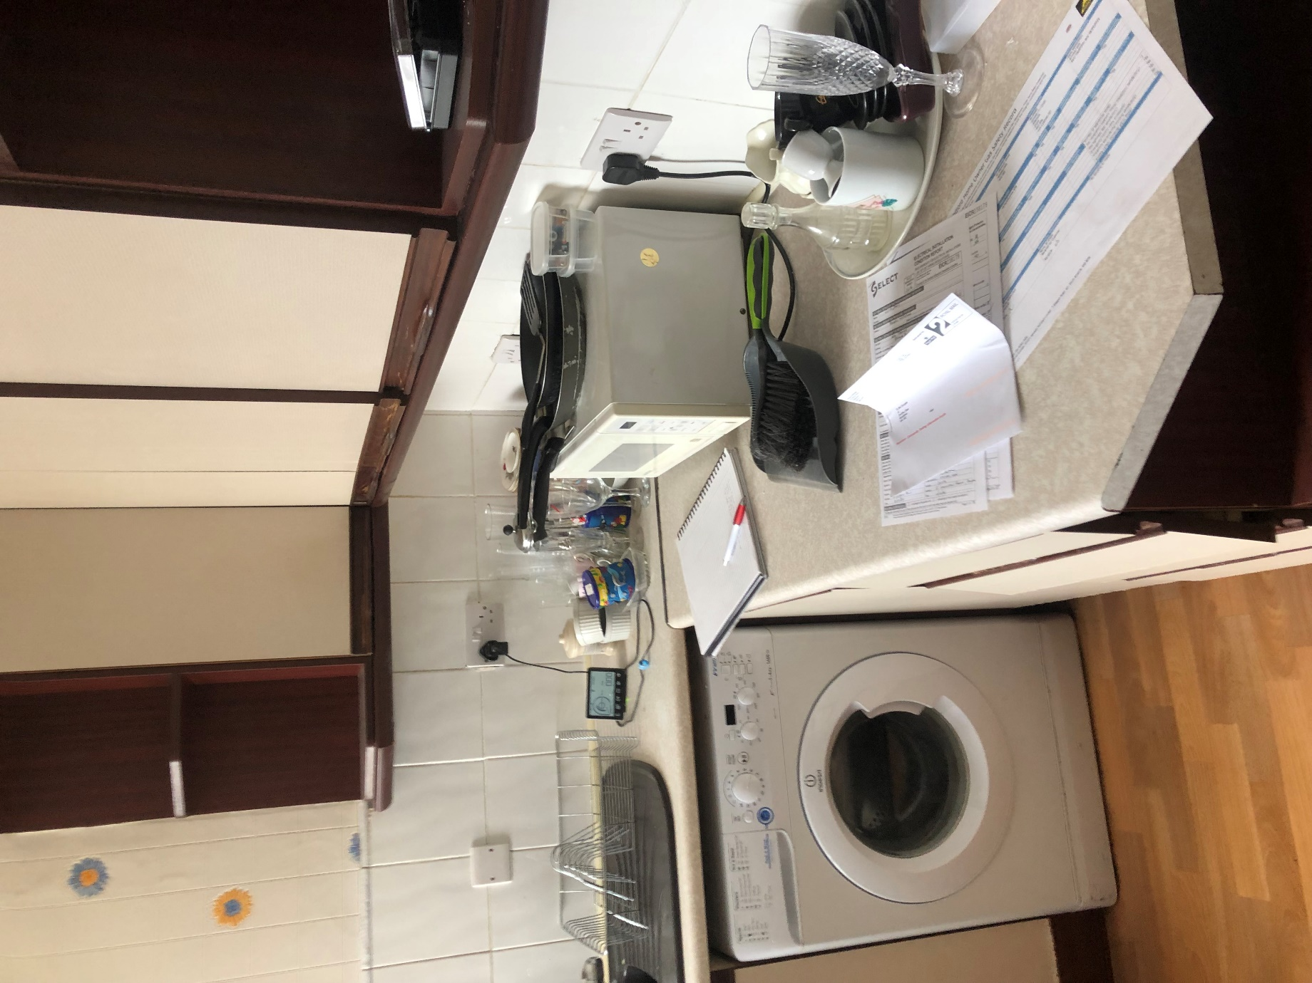

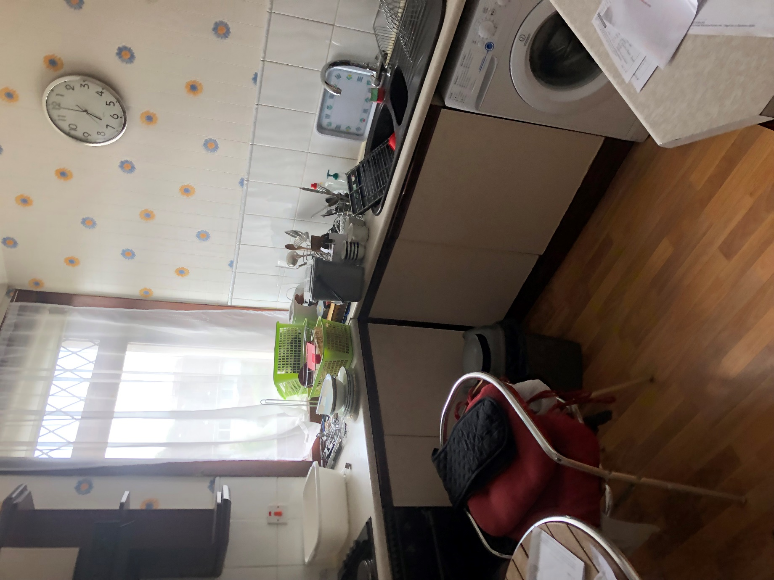

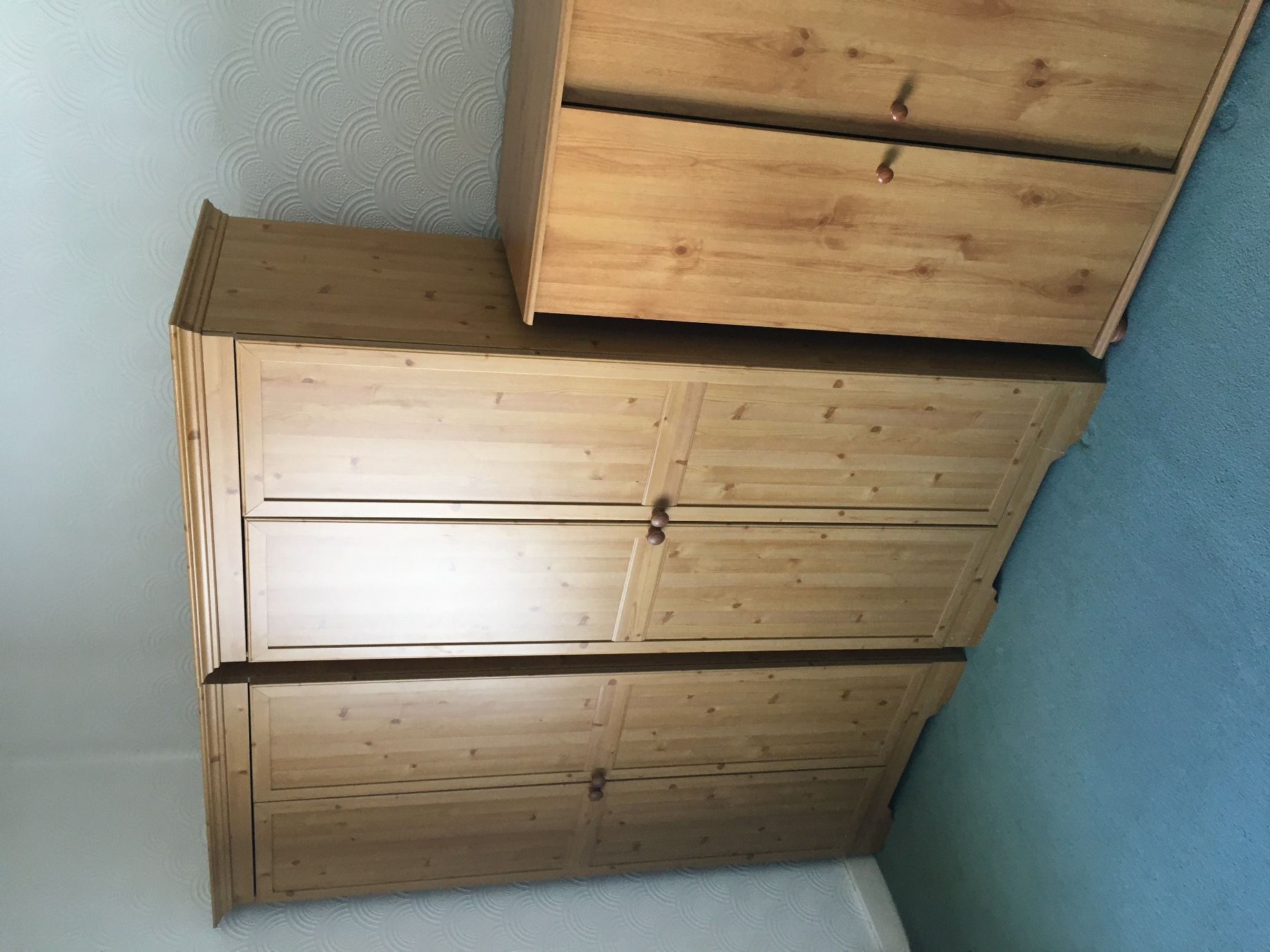

For further Information please contact Norma McGlone at [norma.mcglone@south-ayrshire.gov.uk](mailto:norma.mcglone@south-ayrshire.gov.uk) or [prs@south-ayrshire.gov.uk](mailto:prs@south-ayrshire.gov.uk). Or call on 01292 473477.

Landlord Registration Number- 1469606/370/03092.

Letting Agent Registration Number- LARN2008004