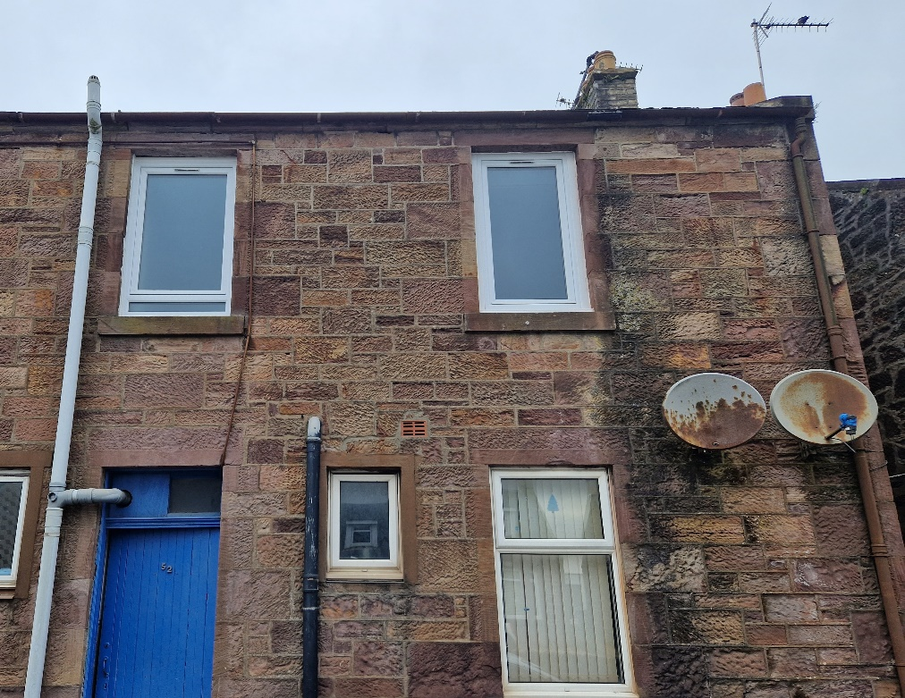

**One Bedroom upper flat, in Maybole.**

Rent £350 per month

EPC Band Rating G

Council Tax Band A

**Features:**

Upper property

New double-glazed windows

Unfurnished

Electric heating

Shower over bath

Communal garden

High ceilings

Pets allowed

Carpet and linoleum throughout

Secure internal close door

**Description**

Your Choice Lettings and Property Management are delighted to present to the market, this one bedroom upper flat, located on Kirkoswald Road, Maybole.

This light and spacious flat is comprised of a double bedroom located at the front of the property, a sizable bathroom with a corner bathtub and overhead shower and an open plan livingroom and kitchen.

The décor of the flat is neutral throughout with a feature wall in the livingroom. The livingroom, hallway and bedroom are carpeted, and the Bathroom and Kitchen are fitted with linoleum. There are new electric heaters installed as well as new front double-glazed windows in the bedroom and bathroom. The close to the flat has an extra security door for access and the property comes with shared access gardens.

The local area has a range of amenities, local convenience stores and café’s, with the swimming pool and golf course just a short distance away. Maybole has great transport links to Ayr and Glasgow via regular buses and trains.

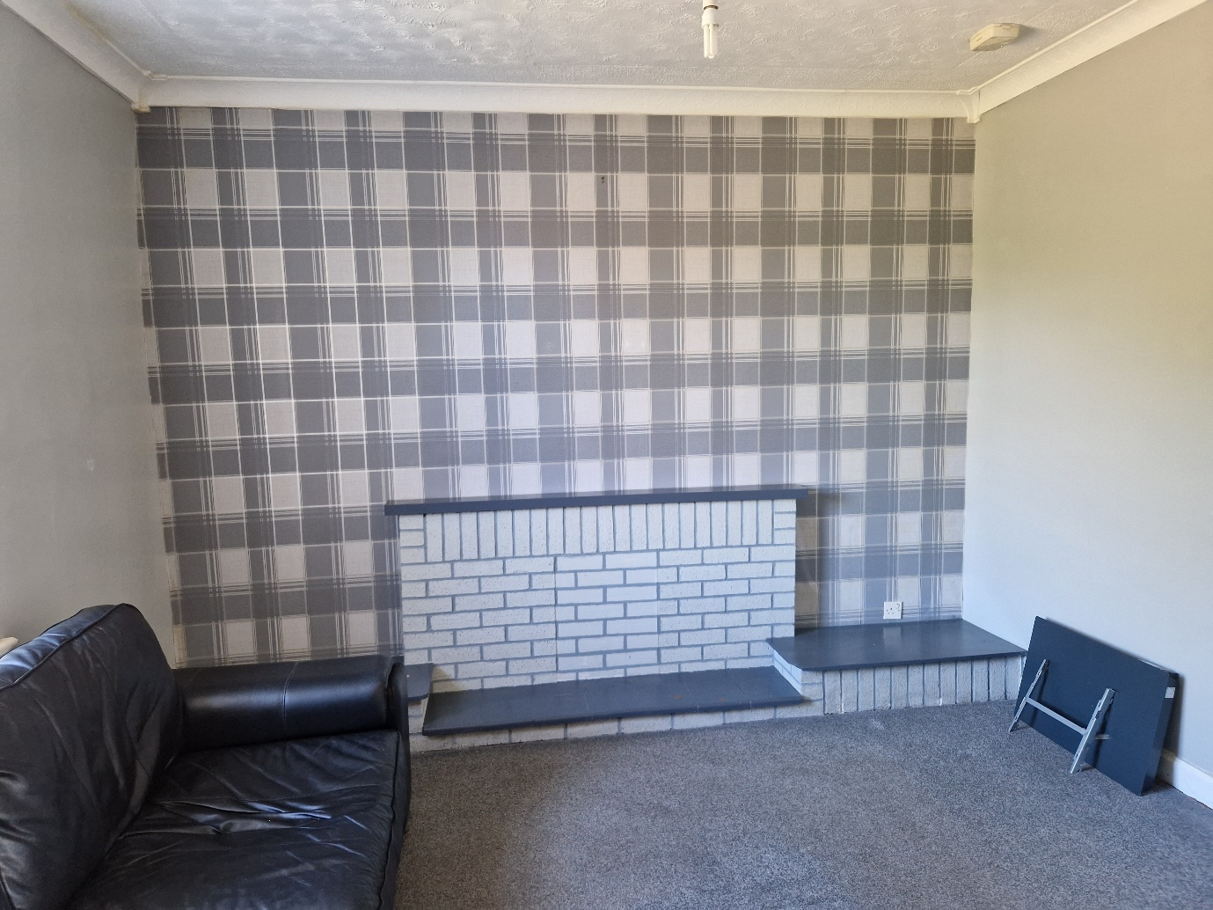Livingroom

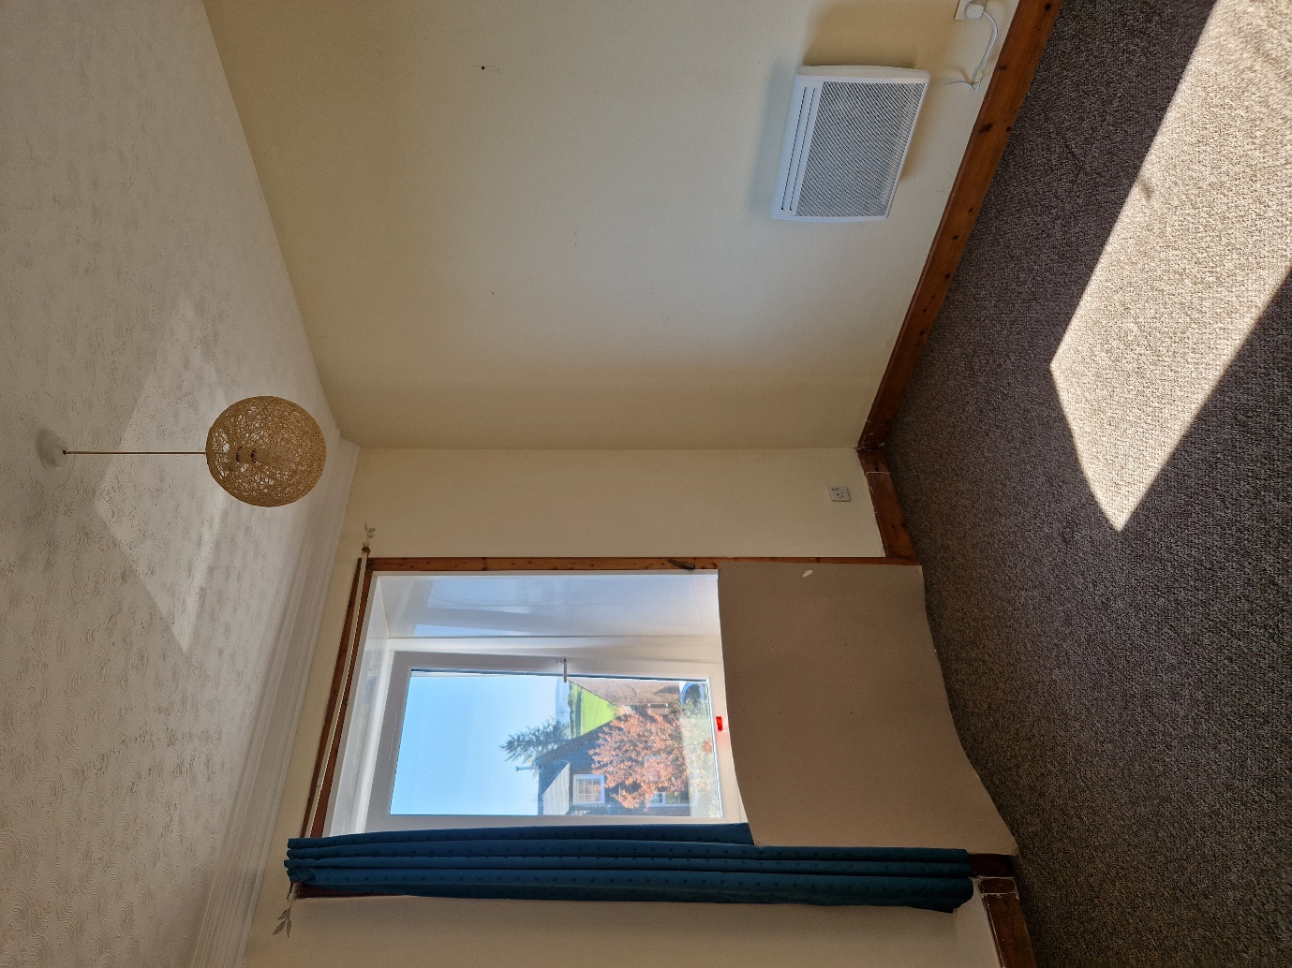

Bedroom

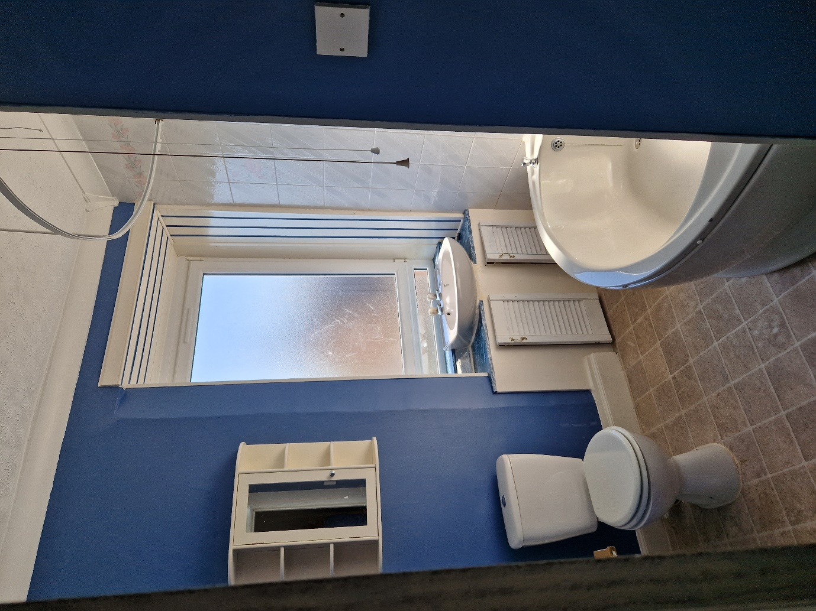

Bathroom

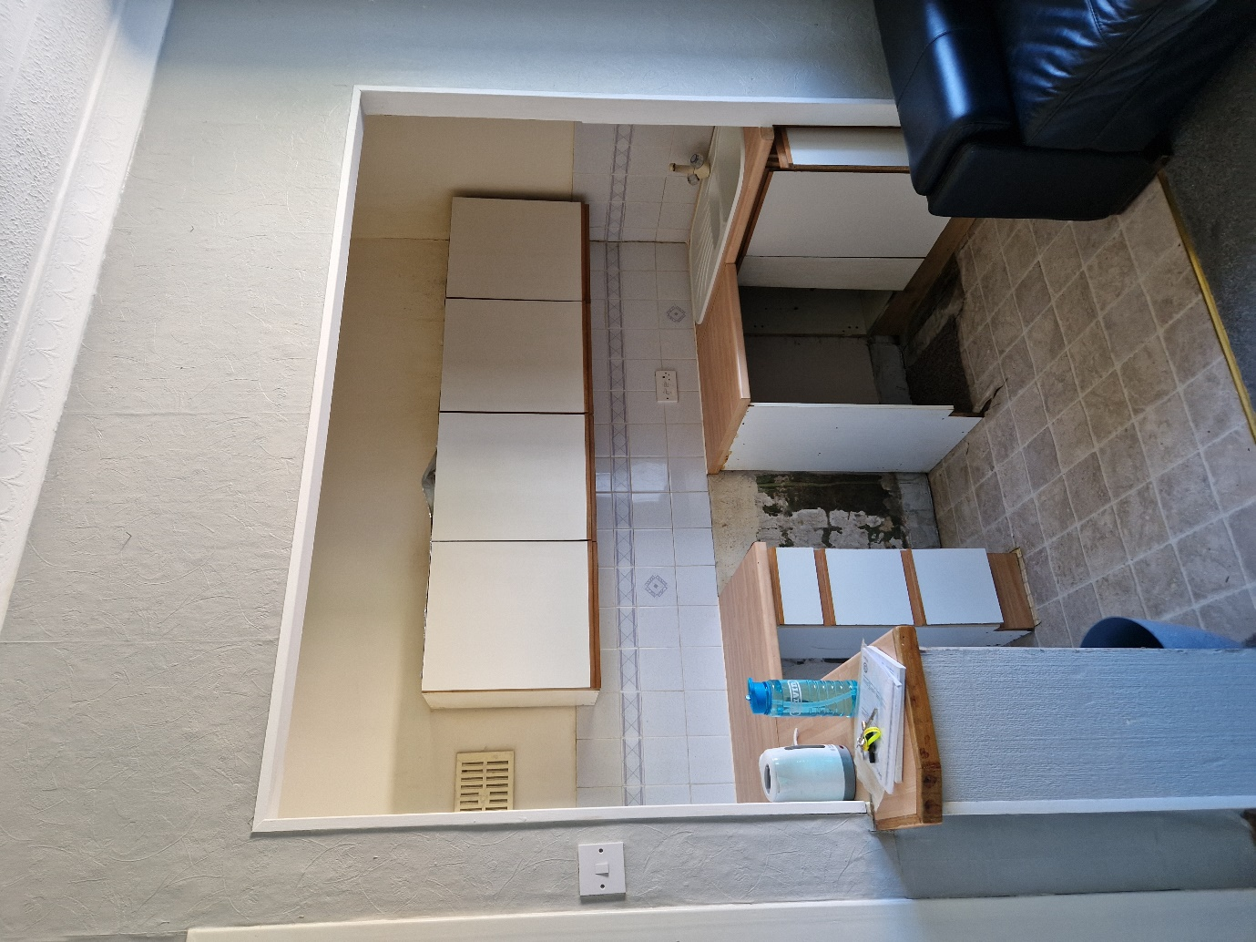

Kitchen

For further Information please contact Kristen Ruckledge at [Kristen.ruckledge@south-ayrshire.gov.uk](mailto:Kristen.ruckledge@south-ayrshire.gov.uk) or Norma McGlone at [norma.mcglone@south-ayrshire.gov.uk](mailto:norma.mcglone@south-ayrshire.gov.uk) or [prs@south-ayrshire.gov.uk](mailto:prs@south-ayrshire.gov.uk). Or call on 01292 473477.

Landlord Registration Number- 1234238/370/13052

Letting Agent Registration Number- LARN2008004