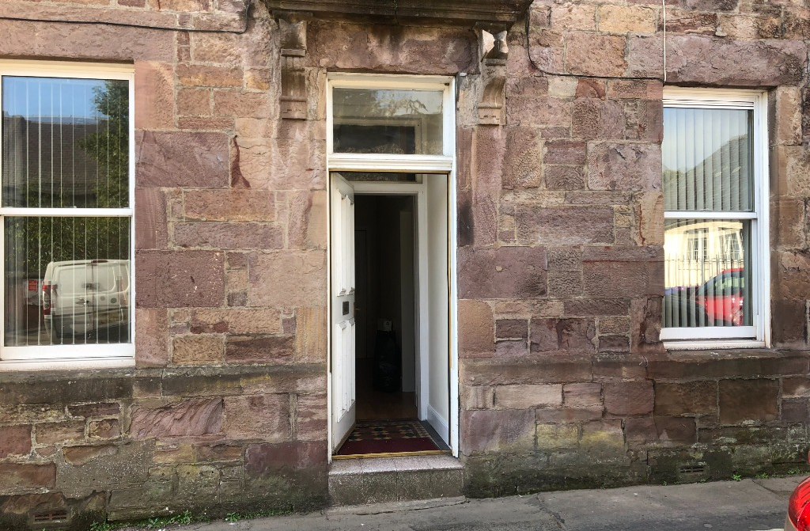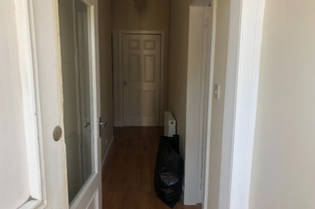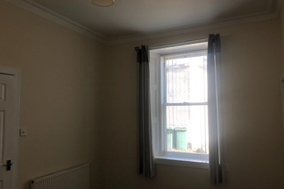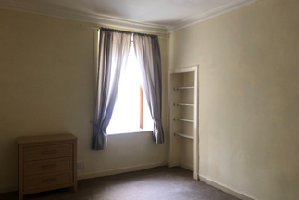

**prs@south-ayrshire.gov.uk**

Email

Phone

**01292 473477**

**Council tax band: B | EPC rating: C**

* Double Glazing
* Gas Central Heating
* Kitchen Diner
* Fridge Freezer
* Tiled Bathroom
* Large Lounge

**2**

**1**

**1**

**Castle Street, Maybole**

**£450 PCM**

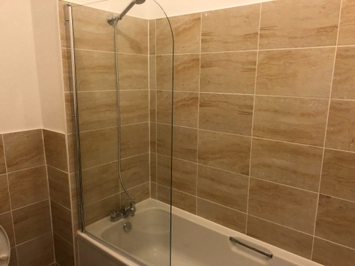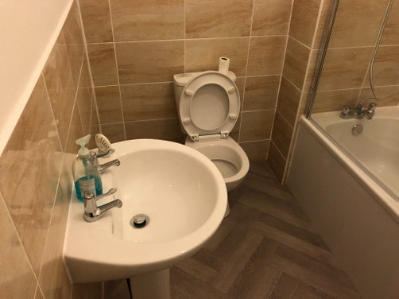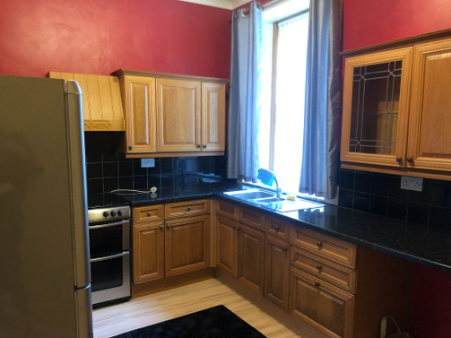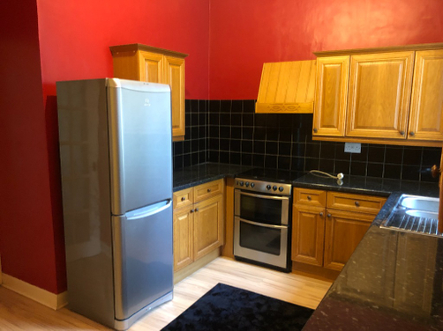

This is a very well presented 2 bedroom ground floor flat in Castle Street, Maybole.

The flat is a traditional build property which has large rooms, own front and back door leading onto a communal garden at the rear.

Large lounge with feature fireplace to front of property with blinds, curtains and wood effect laminate flooring.

2 double bedrooms, 1 at front and one to the raer of property with carpets, blinds and curtains.

Large kitchen with room for a dining table, has a fridge freezer and cooker.

Utility room next to kitchen with boiler and washing machine.

Large tiled bathroom with white suite which includes a shower over the bath with glass shower screen, washhand basin and toilet.

**Photographs**

**Description**

*Large Living room with feature fireplace*

*Bathroom tiled 3 piece suite shower over bath*

*2 Double bedrooms with blinds, curtains and carpet*

*Large dining kitchen*

*Utility room with boiler and washing machine*

*Communal garden*

**Rooms**

**Features**

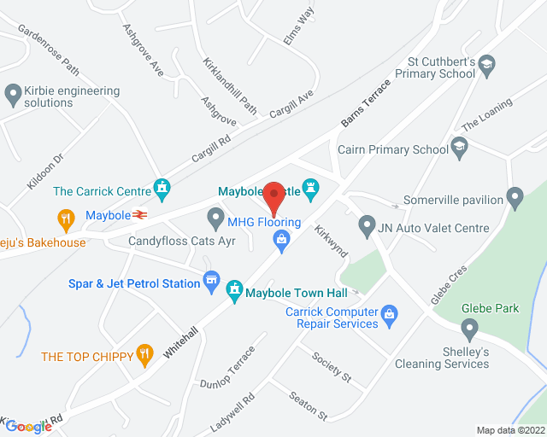

____________________________________________________________________________________________

______________________________________________________________________________________________

______________________________________________________________________________________________

______________________________________________________________________________________________

______________________________________________________________________________________________

______________________________________________________________________________________________

______________________________________________________________________________________________

______________________________________________________________________________________________

______________________________________________________________________________________________

______________________________________________________________________________________________

______________________________________________________________________________________________

______________________________________________________________________________________________

______________________________________________________________________________________________

**Notes**

**Map**

LARN: 2008004

**Your Choice Lettings and Property Management**