**LAND REFORM (SCOTLAND) ACT 2003**

**THE SOUTH AYRSHIRE COUNCIL (CITADEL, COMMUNITIES FUN DAY) EXEMPTING LAND FROM ACCESS RIGHTS ORDER 2022**

SOUTH AYRSHIRE COUNCIL (“the Council”), in exercise of the powers conferred on it by Section 11(1) OF THE Land Reform (Scotland) Act 2003 (“the Act”), in order to exempt land from access rights otherwise exercisable under the Act, hereby makes the following Order:

1 This Order may be cited as “The South Ayrshire Council (Citadel, Communities Fun Day) Exempting Land from Access Rights Order 2022”.

2 The effect of the Order is to exempt from the access rights which would otherwise be exercisable in respect of the land by virtue of Part 1 of the Act, the Citadel Leisure Centre, South Harbour Street, Ayr KA7 1JB together with the adjoining land and paths, all as outlined and hatched in black on the plan annexed to the Order.

3 The purpose for which the Order is made is to enable the South Ayrshire Council Communities Fun Day to be held on, and in the environs of, the Citadel Leisure Centre, with the land being exempted temporarily from access rights in the interests of the safety of participants, spectators and the public during the event.

4 The Order will take effect from 18:00 hours on 09 September 2022 and will expire at 18:00 on 10 September 2022.

This Order, together with the Plan annexed and signed as relative hereto, are subscribed for and on behalf of South Ayrshire Council by Donald Gillies, Director- Place, an authorised signatory and proper officer of the local authority in terms of the Local Government (Scotland) Act 1973 section 193 as amended, at …………………. on………………………………................................................. ................................................

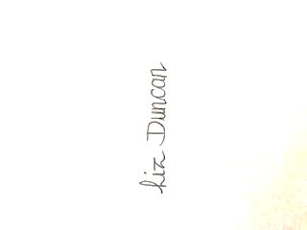

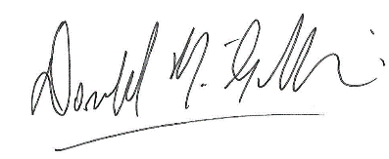

................................................. ................................................

**Donald Gillies-Director, Place Liz Duncan –** **Witness**

**c/o County Buildings,**

**Wellington Square, Ayr KA7 1DR**

RS

30.08.22