Accessible Voting for All

Anyone who’s eligible to vote on polling day should be able to do so in a confident manner. We provide the following to assist you in voting:

Assistance to mark the Ballot Paper | 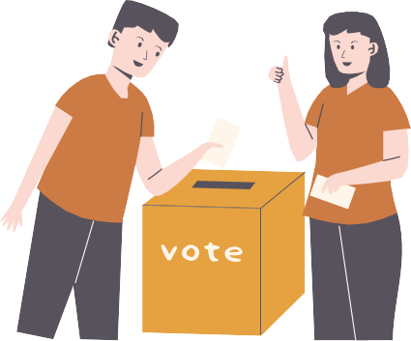
Large Print Ballot Paper |     
Tactile Voting Device | 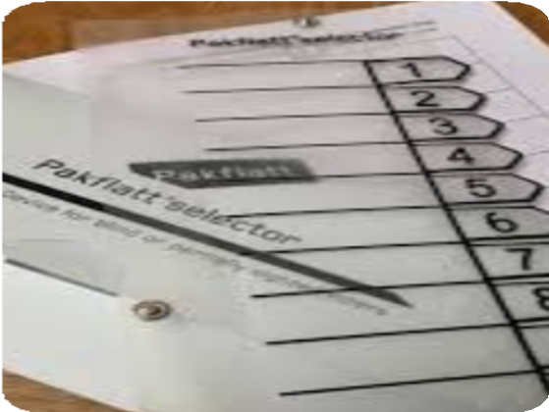
Audio Ballot Paper with Overlay | 
Magnifying Card |   
Pencil Grip | 

Assistance to gain access to the polling station.

If you cannot access the polling station because of a physical disability, the Presiding Officer may take the ballot paper to you. After you have marked your ballot paper, the Presiding Officer will place your ballot paper into the ballot box.

