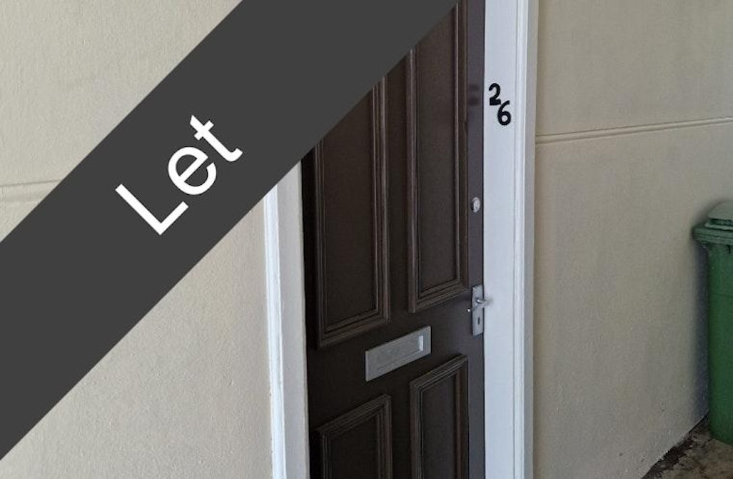





Council tax Band- A EPC Rated Band- D
1 1 1

1
1
1
One bedroom flat in Maybole
£375 PCM

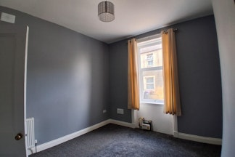
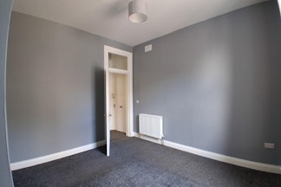
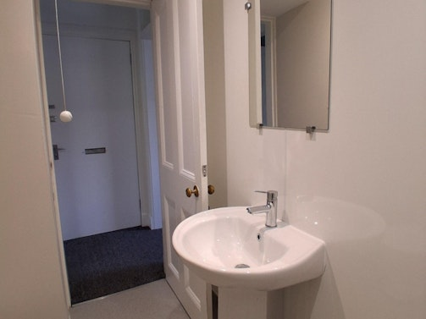
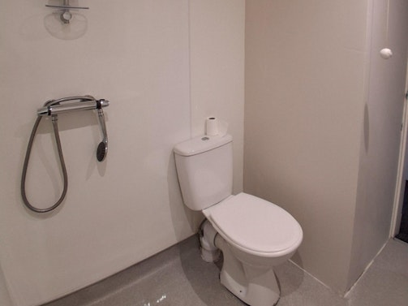
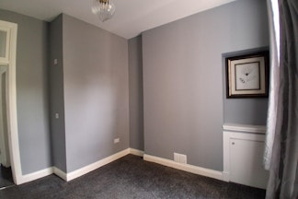
Bathroom

Bedroom

Livingroom
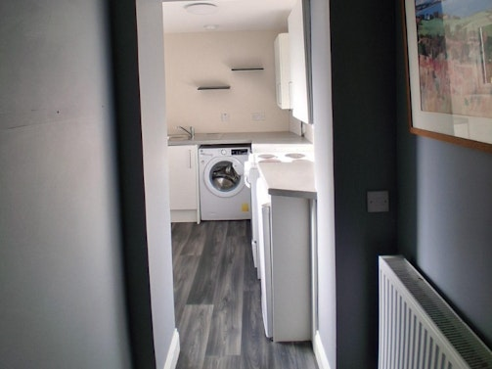
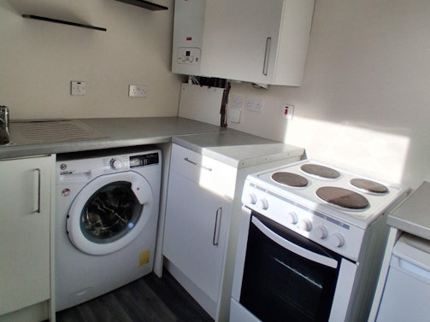
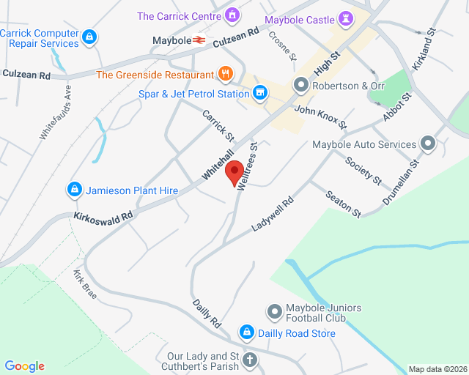
Map

Kitchen
Features
Ground level property (stairs to get into close)
Double Glazed
Gas central heating
Carpet & Lino flooring
Wet Floor Shower room
Electric hob and oven
Undercounter fridge
Washing machine
Pets allowed
Access to low maintenance garden area
Description
Your Choice Lettings and Property Management are delighted to present to the market, this spacious 1 bedroom, ground level flat, in a walk-in condition, located on Welltrees Street, Maybole.
This light and spacious flat, with high ceilings throughout is fully carpeted in the bedroom, hallway and living room. The bathroom has wet room flooring and Kitchen has linoleum flooring. The flat has a double bedroom situated to the front of the building.
The décor of the flat is a neutral colour throughout. The bathroom is a three-piece wet room floor shower room. The kitchen is relatively new and contains a gas boiler, washing machine, under counter fridge, electric cooker hob with oven and grill. From the kitchen, you have access to a very small, low maintenance garden area.
The local area has a range of amenities and great transport links where you will find regular buses and trains to Ayr and Glasgow.

For further information please contact Amy.Cooper@south-ayrshire.gov.uk or Suzie.McIlloney@south-ayrshire.gov.uk
Landlord Registration Number- 157396/370/30090
Letting Agent Registration Number- LARN2008004

Features and description
Notes

