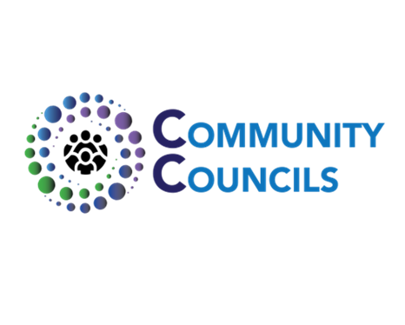
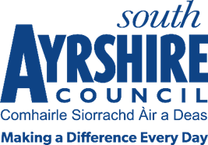
Privacy Notice
Community Councillor Nominations
As the ‘data controller’ for the personal information – or data – we hold about you, South Ayrshire Council decides how your personal information is used/processed, and what it is used for.
This statement provides more details about how the Council uses your personal data when you agree to be nominated as a Community Councillor and/or become a Community Councillor, and provides information on how to get in touch with us if you need to know more.
Your personal data – what is it?
Personal data is information relating to a living person who can be identified from that data. Identification can be based on the information alone, or in conjunction with any other information. The processing of personal data is governed by the General Data Protection Regulation 2016 (GDPR) and supplemented by the Data Protection Act 2018.
What Personal Data will we collect from you?
We will only collect the personal information we need to progress your agreed nomination as a Community Councillor and provide you with relevant information, services and support if you are a Community Councillor in South Ayrshire. The personal data we will collect may include:
§Name
§Address and Postcode
§Land line telephone number
§Mobile telephone number
§Email Address
How will we use your information?
We will use your information for the administration of the election of your community council and support you as a Community Councillor should you be elected to your Community Council.
What is the legal basis for using/sharing your information?
The Council has a statutory obligation to assist community councils in terms of the Local Government (Scotland) Act 1973 and the Local Government (Scotland) Act 1994, which is considered to be our public task.

Who will we share your information with?
When we will collect your personal data | Who we will share it with
When you stand for election as a Community Councillor | - The Public: Your name and address will appear on the election ballot paper (if a Poll is required).  - AVJB: Your name and address will be shared with the Ayrshire Valuation Joint Board to verify your application.
If you are elected to a Community Council | - The Community Council: Your name and address will be passed to the Community Council you have joined to allow them to communicate with you and to allow a Notice to be displayed by the Community Council within the community of your membership.  - The Public: Election results will be posted on the Council’s website, which will include your name, the town where you live and postcode, for openness and transparency of election results.
If you are elected to a key position on your Community Council (e.g. Chair or Secretary, and depending on the role you fulfil): | - The Public: Your name, address, post code, telephone number and email address may be added to the Council’s Community Council web page to allow members of the public to contact you.  - Council Elected Members & Employees: Your name, address, postcode, email address and telephone number will be placed on the Councils intranet to allow Elected Members. Support staff and Council Officers to contact you in for Community Council business.

How long do we keep hold of your information?
We will retain your personal data in line with our corporate records retentions schedule, and hold your data for five years following the last action on your record.

What are your rights?
The lawful basis for processing/using your personal data directly impacts which rights are available to you. For example, some rights will not apply, in this case we are not required to:
§erase your personal information
§enable the right to data portability
However, you do have the following rights and can ask us to:
§correct your personal information if it is inaccurate;
§complete your personal information if it is incomplete;
§restrict the processing of your personal information in certain circumstances
You also have the right to object to the processing of your personal information, under certain circumstances.
What are the consequences of failing to provide personal information?
Where the provision of your information to the Council is a statutory or contractual requirement, or a requirement necessary to enter into a contract, you are obliged to provide the information. If the required information is not provided, the Council will be unable to undertake our statutory functions in terms of the administration and election of Community Councils.
Do you require this statement in a different format?
Please contact us if you require this information in an alternative format.
How can you get in touch with us?
If you wish to obtain any records held by the Council relating to you, or if you have any general data protection queries, please contact the Council’s Data Protection Service at:
Data Protection Officer Email: DataProtection@south-ayrshire.gov.uk
County Buildings Telephone: 01292 612223
South Ayrshire Council
Wellington Square
Ayr KA7 1DR

Are you dissatisfied with the way your Personal Information has been handled?
If you are unhappy with the way we have dealt with your personal information, you can complain to the Council’s Data Protection Officer using the contact details noted above.
If you remain dissatisfied after contacting us, you have the right to complain to the Information Commissioner (https://ico.org.uk/for-the-public/):
Information Commissioner’s Office –  Queen Elizabeth House, Sibbald Walk  Edinburgh EH8 8FT | Email: Scotland@ico.org.uk  Telephone: 0303 123 1115

