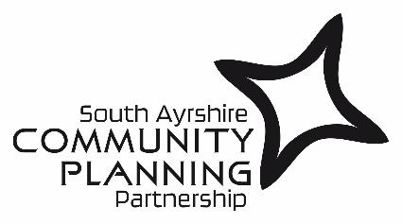

All together – growing, caring and living a better life
CONSULTATION PLAN: Equalities Outcomes 2025-2029

Developed with guidance from SAC Community Engagement Strategy 2020

Inclusion:
We will identify and involve the people and organisations that are affected by the focus of the engagement.
Engagement has taken place with the community & staff through consultation. The survey has been shared widely across services within SAC as well as through existing groups like the SAC1000, Community Planning Participation and Engagement Group (CPPEG) and the South Ayrshire Access Panel to try to reach a wider audience. HSCP Engagement Officers have shared with Locality Planning Partnerships. As well as sharing with our Equality & Diversity forum The Youth Council has also been consulted via education staff.
Support:
We will identify and overcome any barriers to participation.
We will take the advice and expertise from the CPPEG to ensure that any barriers to participation are highlighted and through members of that group, engagement and consultation will be adapted where appropriate. We will ensure that our consultation is in plain English and that our local communities can identify what the equality outcomes are and what they mean.
Planning:
There is a clear purpose for the engagement, which is based on a shared understanding of community needs and ambitions.
In coming up with the themes, we have considered the following:

South Ayrshire Council and South Ayrshire Health and Social Care Partnership - SAC Council Plan (2023-2028) & HSCP Integration Joint Board Strategic Plan (2021-2031)

The purpose of the consultation is to seek views on our new Equalities Outcomes 2025- 2029. The ambition of our new outcomes is to reduce inequalities and improve outcomes for everyone in South Ayrshire.
Working Together:
We will engage and work effectively together to achieve the aims of the engagement.
We will seek support from our partners at the HSCP and CPPEG. A variety of communication methods will be used. A copy of the consultation mandate is attached as appendix 1.
Methods:
We will use methods of engagement that are fit for purpose.
A variety of methods will be used for engagement including general consultation through the SAC website. The CPPEG/HSCP will use the most appropriate method of engagement specific to each of the groups that members represent.
Communication:
We will communicate clearly and regularly with people, organisations and communities affected by the engagement.
We will provide feedback on the outcome of the engagement. We will consider the feedback in light of our outcomes and collectively agree where changes need to be made (if required) in respect of the responses.
Impact:
We will assess the impact of the engagement and use what we have learned to improve our future engagement.
We will be open and transparent and will include detailed information on the consultation process including feedback on the engagement within our Equality Outcomes 2025-2029 and provide information on any changes as a result. We will also include as evidence within our Integrated Impact Assessment.
CONSULTATION TIMELINE
- 24th January 2025 till 23rd February 2025

Appendix 1

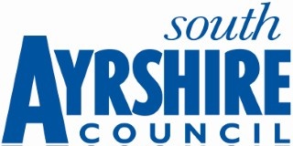

Consultation Mandate
The Consultation Mandate provides clarity for those involved in the consultation process. The following template should be used by those responsible for the development and delivery of the process. A well-constructed mandate ensures that everyone is clear about the purpose of the consultation.

Contact Name: Elizabeth Dougall
Contact Service: Performance and Community Planning, Strategic Change and Communities Directorate
Contact Email: Elizabeth.dougall@south-ayrshire.gov.uk

Final date for comments: 23rd February 2025

Consultation Mandate | Equalities Outcomes 2025-2029
Community Planning Partnership | South Ayrshire Council is looking to undertake consultation regarding developing our new Equality Outcomes 2025-2029 to reduce inequalities and improve outcomes for everyone in South Ayrshire.
need to hear the views of… | We are seeking the views of wider Equality & Diversity Forum, communities of interest (though the Community Planning Participation and Engagement Group). staff and wider general public.
about… | National guidance on setting Equality Outcomes notes that these should be proportionate and relevant to the functions and strategic priorities of the organisations setting them, and that they may include both short term and long-term benefits for people with protected characteristics.  Setting equality outcomes help us to ensure the interests of people from all backgrounds, especially those with protected characteristics, are reflected in the work we do. It also helps us to meet the requirements of the Equality Act 2010, by working to eliminate discrimination, advance equality, and foster good relationships between diverse groups.
so that… | The responses from the consultation will be collated and the information provided used to guide and shape the Equality Outcomes 2025-2029.
Can… | The responses will be shared with the Equality Outcomes Short-life Working Group to ensure the priorities proposed are fit for purpose.
On / by… | January 2024 (for a period of 4 weeks) – consultation to take place with wider Equality & Diversity Forum, community planning partners, communities of interest (through the Community Planning Participation and Engagement Group) and wider general public.
so as to accomplish… | A robust set of Equality Outcomes for the period 2025-2029.
Communications Team Support requested i.e. Social Media and Webmaster | The consultation will be shared with the Communications Team to allow the link to the survey to be shared across South Ayrshire.

