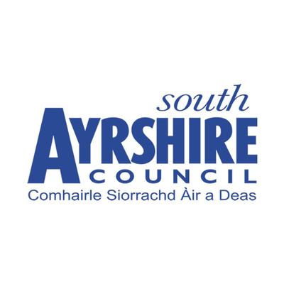

South Ayrshire Council

County Buildings

Wellington Square

Ayr KA7 1DR

**FOR SALE**

**LAND**

**FORMER AFFLECKS SITE**

**AYR**

**LOCATION**

Ayr is the administrative and principal retail centre for Ayrshire with a populaton of around 48,000 persons and a catchment populaton in excess of 180,000 persons. The town is situated approximately 40 miles south‐west of Glasgow City Centre.

The land is situated between Ayr High Street and New Bridge Street.

**DESCRIPTION**

The area of land forms part of the building known as Afflecks which was demolished a number of years ago.The area is currently overgrown and is landlocked. There is an electricity sub-station on site.

**SERVICES**

No information is held with regards to any services on site. Any prospective purchaser should make their own enquiries.

**RATEABLE VALUE**

The land does not currently have a rateable value. Any change of use may result in the land being assessed by the Ayrshire Vluation Joint Board..

**SALE**

Offers are invited for the Council’s freehold interest in this land.

**PLANNING**

The Council is currently awaiting a planning brief for the site.

It is recommended that interested parties contact the Council’s Planning Service on 01292 616 107 or e-mail: - [planning.development@south-ayrshire.gov.uk](mailto:planning.development@south-ayrshire.gov.uk) for further information.

**PROFESSIONAL FEES**

The ingoing tenant will be responsible for the Council’s professional fees as well as any stamp duty land tax (SDLT) incurred in this transaction.

**OFFERS**

Formal written offers to purchase the Council’s freehold interest in this property are invited. **Offers submitted in any other format will not be considered.**

A closing date for offers may be fixed and parties are advised to register their interest by e-mailing the Council’s Estates Section.

**CONTACT**

For further information and to arrange a viewing please contact the Estates Section – 01292 612914 or e-mail:

Robert Campbell: - [robert.campbell@south-ayrshire.gov.uk](mailto:robert.campbell@south-ayrshire.gov.uk)

Louse Muir:- [Louise.muir2@south-ayrshire.gov.uk](mailto:Louise.muir2@south-ayrshire.gov.uk)

South Ayrshire Council gives notice that these particulars are not warranted, nor do they constitute any part of any offer or contract and all statements contained herein are made without any responsibility on the part of the Council and/or its employees. Further, neither South Ayrshire Council and/or its employees are authorised to make or give any representation of warranty in respect of the property described in this brochure. South Ayrshire Council is not obliged to accept the highest, nor any offer.

