

Elected Members Module Guide

May 2022

Overview

URLs
The elected members module can be found using the links below, these are links to the pre-production version of the module, meaning that submissions can be made and edited without appearing on the live site.
Submit a member enquiry
https://thecore.south-ayrshire.gov.uk/article/40276
Member dashboard
https://thecore.south-ayrshire.gov.uk/article/40277/Member-Enquiries-Dash-Board
Assist elected members
https://thecore.south-ayrshire.gov.uk/article/40365/
Tasks
https://thecore.south-ayrshire.gov.uk/tasks

Logging in
Users must be logged in to access the members module. Your login details will be the same as the ones used to access The Core.

Assist
To access the members module on behalf of an elected member, navigate to the ‘assist’ page via the link above. From there, you will be able to search for a specific elected member that you would like to submit an enquiry on behalf of.
Once located, click ‘view details’ and from there, you should see a shortcut to the member enquiries section. Which will give you access to both the ‘submit’ page and the member’s dashboard
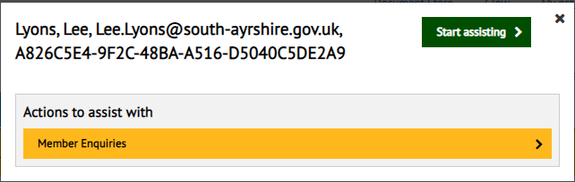

Members Dashboard
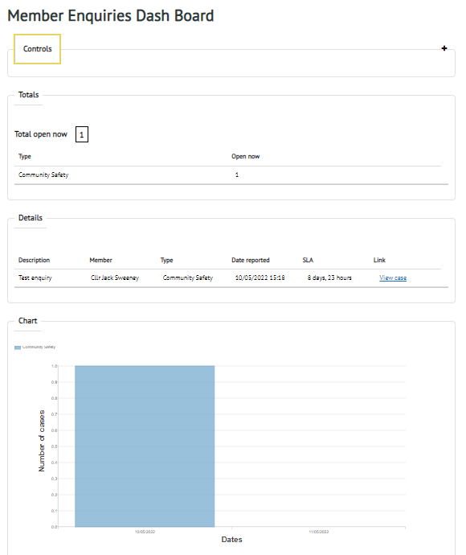
The members dashboard gives elected members an overview of all enquiries related to them both open and closed. Only elected members can access this section. From this dashboard, members can see any enquiries that they themselves have submitted as well as enquiries submitted by other members which have been shared across their ward or party.

Filtering
Enquiries can be filtered by type via the ‘Controls’ bar at the top of the dashboard. The types currently listed allow users to show/hide tasks related to specified teams and services

Updates
The data displayed on the members dashboard does not update immediately. This means that any new enquiries will not display right away, however they should appear after 5 minutes

Member Enquiries
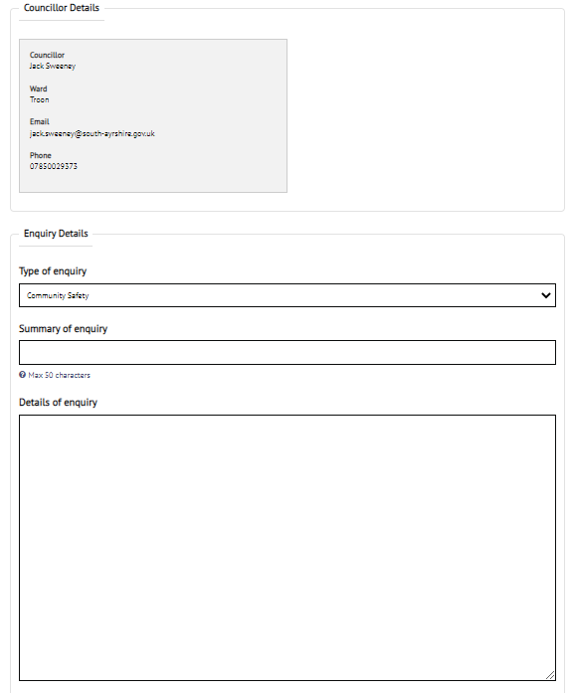
When logged in, councillors also have access to the ‘Submit a member enquiry’ page, provided they have been added to the admin group. To do this, navigate to the ‘Submit a member enquiry’ link on the landing page. Only elected members have access to this page, other staff and case managers will only be able to see any enquiries once they have been submitted

Submitting an enquiry
When using this section, multiple fields will be required before the enquiry can be submitted:
- Summary of enquiry – A short description of the enquiry
- Type of enquiry – The service area that the enquiry relates to (Once submitted, the enquiry will be reassigned to the service selected from this drop-down)
- Details of enquiry – A more in-depth summary of the enquiry. This can be used to include more details and allow the team dealing with the enquiry to gather more information
- Attachments – Any document that may relate to the enquiry (This can be any type of document e.g. pictures, documents, screenshots etc)
- Priority – This can be set as ‘Low’, ‘High’ or ‘Medium’ and will allow staff to prioritise certain enquiries
- Councillor details – This area of the form will change depending on who is submitting the enquiry. It should contain your own councillor details
- Constituent details – This section is optional. If the constituent would like to remain anonymous or their details don’t relate to the enquiry, this can be skipped
- Privacy preferences – When an enquiry is submitted, it can be shared with other members in your ward or members of your party within your ward. If shared, this enquiry will appear on their members dashboard as well as your own, depending on the option selected. Alternatively, if you would like this enquiry to only display in your own dashboard ‘Do not share’ can be selected.
There is also a ‘save’ button located at the bottom of the page throughout this form, meaning that the information entered and returned to at any time.
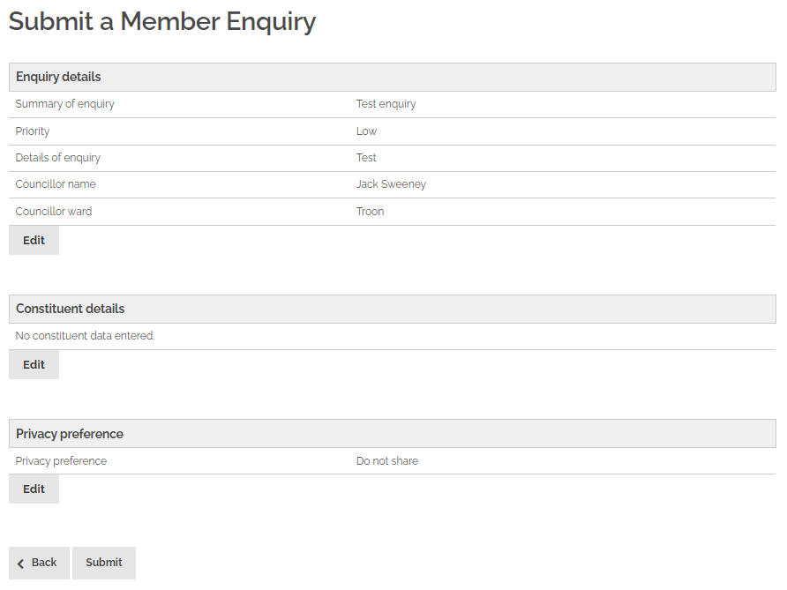
Once the information has been filled in, you will be shown a summary of the enquiry. If the information within this summary is correct, click ‘submit’ and if any information needs to be changed click ‘Back’ to go back through the form

Once submitted, the form will be sent to the team selected from the ‘Request type’ dropdown. If no team or ‘Other’ has been selected, the enquiry will be sent to the main member enquiries admin group, where it can be assigned manually.
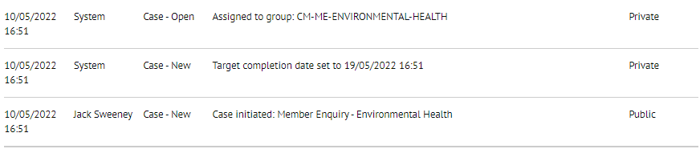
When the selected team have worked through the enquiry, and completed any tasks related to the enquiry, it will be completed and can be reassigned back to CM-MEMBER-ENQUIRY for review by staff who will then close the case.
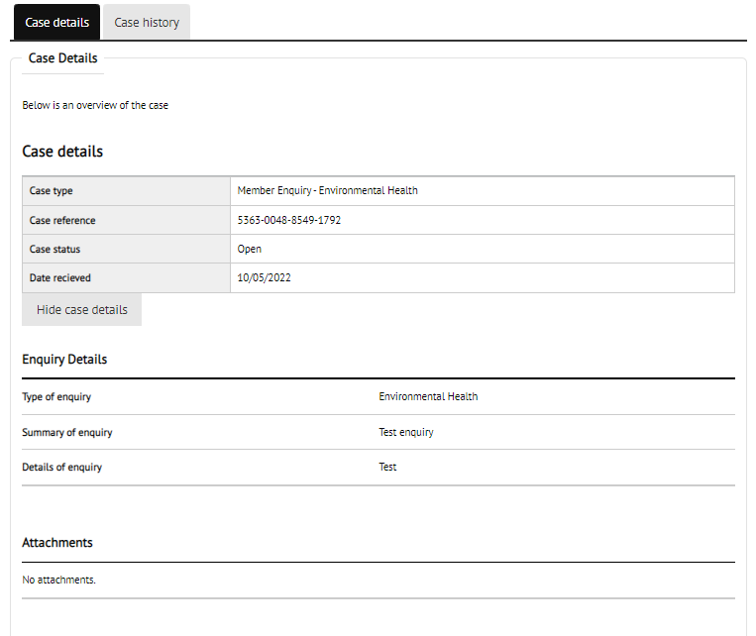
Throughout this process, these enquiries will still be available to view via the members dashboard as well as your task list.

Time allocation
Once an enquiry has been submitted, a time limit of 10 days is applied to it. If this time limit is exceeded or 10 days pass without progression, an email reminder will be sent to the case manager and the enquiry will be escalated.

